Top Up Manually

Document Information

|  |  |
| --- | --- |
| **Document Title** | Title of use case – Verb Noun phrasing is almost always the most appropriate! |
| **Document Owner** |  |
| **Version** |  |
| **Status** |  |
| **Date** |  |

1. Brief Description

This use case describes the process of School Administrator manually topping up a student's account balance.

1. Actors

* School Administrator

1. Trigger

The School Administrator needs to manually top up a student's account balance.

1. Pre-Conditions

* The School Administrator must be logged into the system.
* The student's account already exists on the system.

1. Post-Conditions

* The student's account balance is increased by the amount topped up.
* A record of the top-up is created in the system.

1. Basic Flow
2. The School Administrator navigates to “Balance Management” section.
3. The system displays a list of students in the system and their current balance.
4. The School Administrator selects the student whose account they wish to top up.
5. The School Administrator selects the “Top up” button.
6. The School Administrator enters the amount they wish to top up the student's account with.
7. The School Administrator confirms the top-up amount.
8. The system updates the selected student's account balance with the new top-up amount.
9. The system generates a record of the top-up in the system.
10. Alternate Flows
11. Exception Flows

* 6a: If the system calculates total balance is negative, the systems displays an error message to inform the School Administrator enter another greater top-up amount.

1. Business Rules

* There is no limit on the amount that can be manually topped up by the school administrator.
* The top-up amount can be negative.
* The total balance must be positive.

1. Non-Functional Requirements

* The system should process the balance calculating quickly (1s).
* The system should provide clear and concise messaging the top-up process.

1. Supplemental Requirements
2. Visual Model

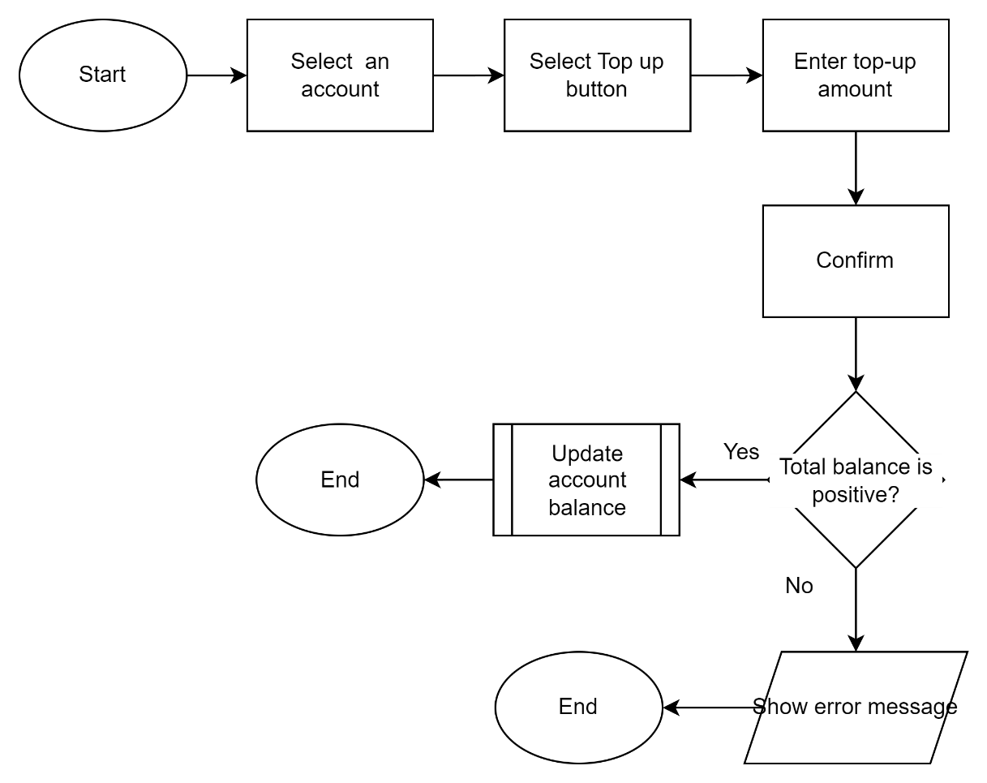

Revision History

|  |  |  |  |  |
| --- | --- | --- | --- | --- |
| V. | Date | Author | Description | Status |
|  |  |  |  |  |
|  |  |  |  |  |